__________________________________________________________________

**Central Florida Regional Planning Model**

**Version 6.1**

**Supplemental User’s Guide**

__________________________________________________________________



**Prepared for the**

**Florida Department of Transportation**

**Updated By**

**Kittelson & Associates**

225 East Robinson Street, Suite 450

Orlando, Florida 32801

&

**WSP|Parsons Brinckerhoff**

Capital Plaza II

301 E. Pine Street

Orlando, FL 32801

**March 22, 2017**

Table of Contents

1 Introduction 1

1.1 Official Model Download 1

2 Graphical user interface (GUI) 3

2.1 Design and Use of the Scenario Control for the GUI 3

2.2 Catalog Keys 8

3 subarea application 10

3.1 Catalog Keys 10

3.2 Use of the SubArea Application 11

4 MPO Reporting 17

4.1 Network Preparation 17

4.2 Summary Reports 19

5 Using Unused Zones 23

List of Tables

Table 2‑1: New or Modified Catalog Keys 8

Table 3‑1: SubArea Application Catalog Key Definitions 10

Table 3‑2: MPO_DIST Catalog Key Definitions 11

Table 3‑3: UserDefinedSubarea Catalog Key Definitions 13

Table 4‑1: MPO Numbers in Highway Network 18

Table 4‑2: MPO Specific Range 18

Table 5‑1: MPO/TPO Zone Ranges 24

List of Figures

Figure 1‑1: FSUTMS Website 1

Figure 1‑2: District 5 Model Page 2

Figure 1‑3: CFRPM Model Download Post 2

Figure 1‑4: Model Download Links 2

Figure 2‑1: Opening the Scenario Control User Interface 3

Figure 2‑2: CFRPM GUI Page 1 4

Figure 2‑3: CFRPM GUI Page 2 5

Figure 2‑4: CFRPM GUI Page 3 6

Figure 2‑5: CFRPM GUI Page 4 6

Figure 2‑6: CFRPM GUI Page 5 7

Figure 2‑7: CFRPM GUI Page 6 7

Figure 2‑8: Catalog Keys in GUI 9

Figure 3‑1: SubArea Application Keys 10

Figure 3‑2: Pre-Defined Districts 12

Figure 3‑3: Select District/Zone Option 12

Figure 3‑4: User Defined Subarea Steps 13

Figure 3‑5: User Defined Subarea Step 1-Edit Network 14

Figure 3‑6: User Defined Subarea Step 2 – Clear Selection Sets 14

Figure 3‑7: User Defined Subarea Step 3 – Select Subarea Polygon 15

Figure 3‑8: User Defined Subarea Step 4- Save/Set Selection Set 15

Figure 3‑9: User Defined Subarea Final Step 16

Figure 4‑1: MPO Attribute 17

Figure 4‑2: Model Report Application 19

Figure 4‑3: Summary Report Location 20

Figure 4‑4: Summary Report Initial Page 20

Figure 4‑5: Example Trip Generation Report 21

Figure 4‑6: Example Congested Travel Time Graphic 22

Figure 5‑1: Districts and Unused Zones 23

List of Appendices

None

List of Acronyms

CFRPM Central Florida Regional Planning Model

FDOT Florida Department of Transportation

GUI Graphical User Interface

LRTP Long Rang Transportation Plan

MOE Measure(s) of Effectiveness

MPO Metropolitan Planning Organization

TAZ Transportation Analysis Zone

**TPO** Transportation Planning Organization

# Introduction

The Florida Department of Transportation (FDOT) District 5 developed a new version of the Central Florida Regional Planning Model (CFRPM) called CFRPM 6.0. This model was developed for the 2040 update to the LRTPs for the five MPO/TPOs within the District. The 6.0 model served as the officially adopted model for the region. Upon its release, the CFRPM 6.0 model was updated with changes made to the user interface and catalog to make it easier to perform standard model tasks, becoming CFRPM version 6.1

A complete user guide is not available for the CFRPM 6.0 version of the model, however this document serves as the guide for usage of the new components of CFRPM version 6.1.

The remaining sections of the document include:

* Use of the Model Control Menu
* Subarea Analysis Process
* Customized MPO Reporting
* Use of Dummy/Unused Zone Centroids

## Official Model Download

To download the official CFRPM 6.1 model users must access the FDOT website: <http://www.fsutmsonline.net/>

1. 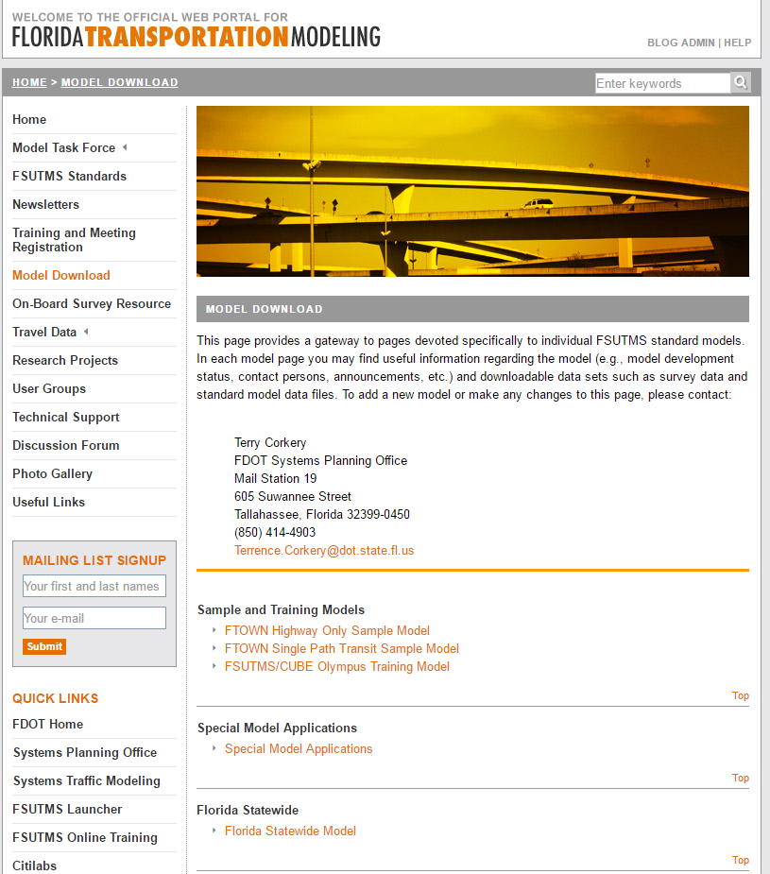Once on this website the user can click on the “Model Download” menu on the left side of the page as shown in Figure 1‑1.

Figure 1‑1: FSUTMS Website

1. Scroll down the webpage until the section for District 5 Models can be seen as shown in Figure 1‑2 and click on the CFRPM model link.

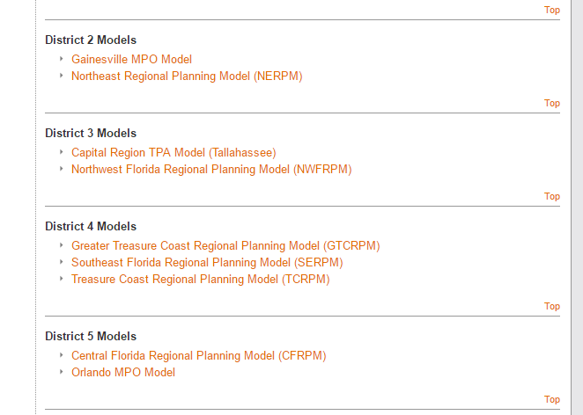

Figure 1‑2: District 5 Model Page

1. A new page will bring the user to the district page. Scroll down to the link to the CFRPM Version 6.1 post and click on the orange title (Figure 1‑3) to get to the file download page as shown in Figure 1‑4.

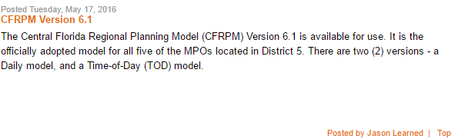

Figure 1‑3: CFRPM Model Download Post

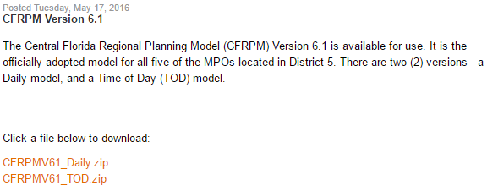

Figure 1‑4: Model Download Links

1. Depending on the intended use, the user can download the daily model or the time of day (TOD) model from the links.

# Graphical user interface (GUI)

A GUI is a software interface designed to standardize and simplify the use of computer programs, by using a mouse to manipulate text and images on a display screen featuring icons, windows, drop down menus and text boxes. Several different models from around the state of Florida were obtained to see what components of their GUIs would be of interest for CFRPM. The result is the interface described in this section of the report. This section of the report will discuss the Design and Use of the Scenario Control for the GUI and the Catalog Keys.

## Design and Use of the Scenario Control for the GUI

The scenario user control interface may be accessed by double-clicking on a scenario item in the scenario list, typically shown in the upper left corner of the user application window in CUBE, as shown in Figure 2‑1.

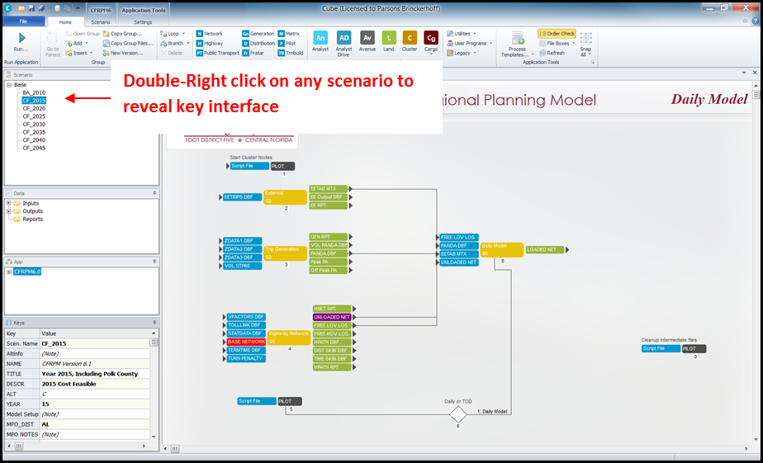

Figure 2‑1: Opening the Scenario Control User Interface

This will reveal the first page of the scenario control user interface, which allows the user to specify various key values, both numeric and string-based that help define the scenario. The GUI varies slightly between the Daily and TOD models, therefore screenshots may be slightly different for a user depending on the version being used in application[1]. The user can determine if they are using the daily or TOD models by referring to the top of the scenario screen as shown highlighted by the yellow box in Figure 2‑2.

The GUI has multiple pages that help the user define the alternative being run, the steps of the model, as well as the model parameters. Figure 2‑2 through Figure 2‑7 show the pages of the CFRPM GUI.

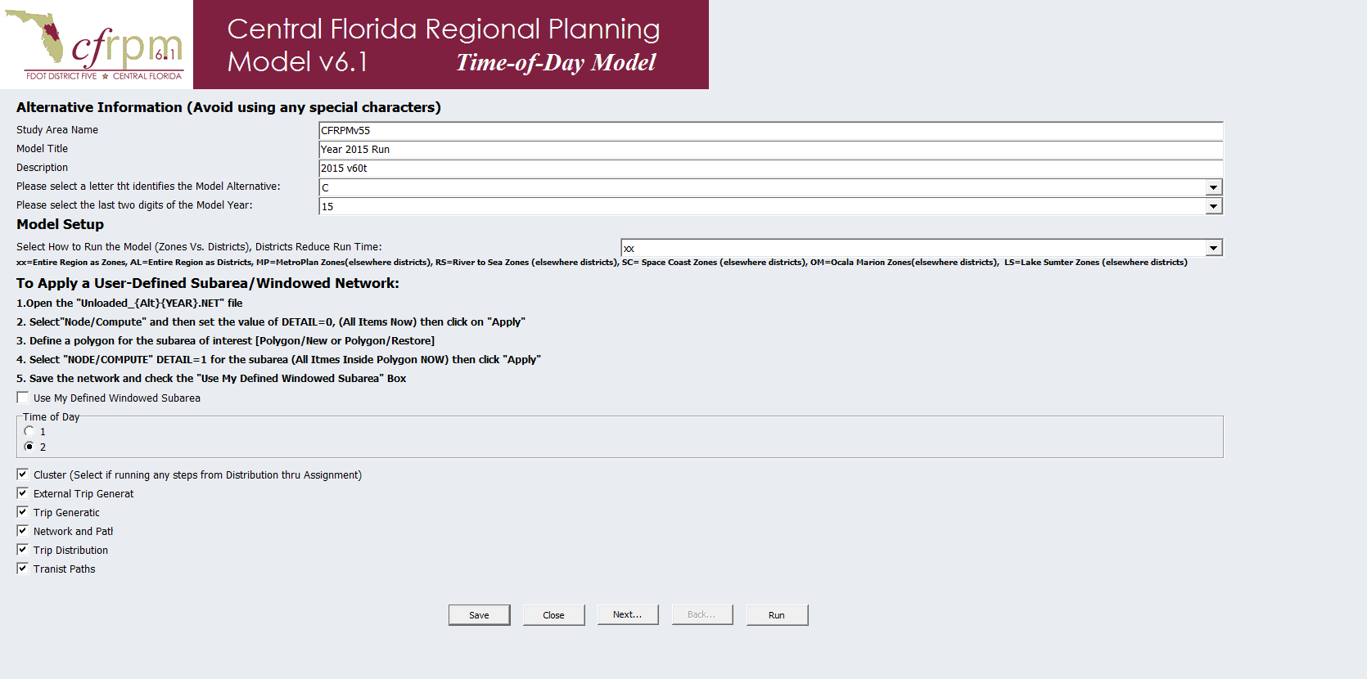

Figure 2‑2: CFRPM GUI Page 1

The flow of the GUI begins with the Alternative Information which includes the Study Area Name, Model Title, Description, alternative letter, and last two digits of the alternative year as shown by the red highlighted box in Figure 2‑2. The user should note that the Name, Title, and Description fields are character strings and should avoid special characters. Both the alternative letter and two digit year are drop down lists the user can use to specify the model scenario.

The next section of the GUI contains the Model Setup and is highlighted by the green box in Figure 2‑2. This section allows the user to select how the model is to be run by allowing for the selection of districting (the implementation of districting allows the user to save significant model run time by reducing the number of zone to zone pairs required to be run by the model). The selections are to run the model for a single MPO where the selected MPO is run by TAZs and the remainder of the model is run by districts, or to run the entire model as districts or finally to run the entire model as TAZs. This is done through a drop down list and the explanation for each option are denoted under the drop down menu.

The user can choose to implement the subarea analysis option in this section of the GUI. The explanation of using the subarea process is outline in Section 3 of the guide.

The section of the GUI highlighted by the blue box in Figure 2‑2 and continued in Figure 2‑3 is where the user controls the execution of individual model steps. This is done by putting a check mark in the box of the step(s) the user wishes to run. This includes the activation of Cube Cluster and also the selection of outputting MPO specific reports or the entire model report. Caution should be observed when selecting or de-selecting these steps so that the resulting model run does not skip intermediate model steps; and that the necessary input files are available when starting the model after the initial step. The details of the MPO Reporting are explained in Section 4 of the guide.

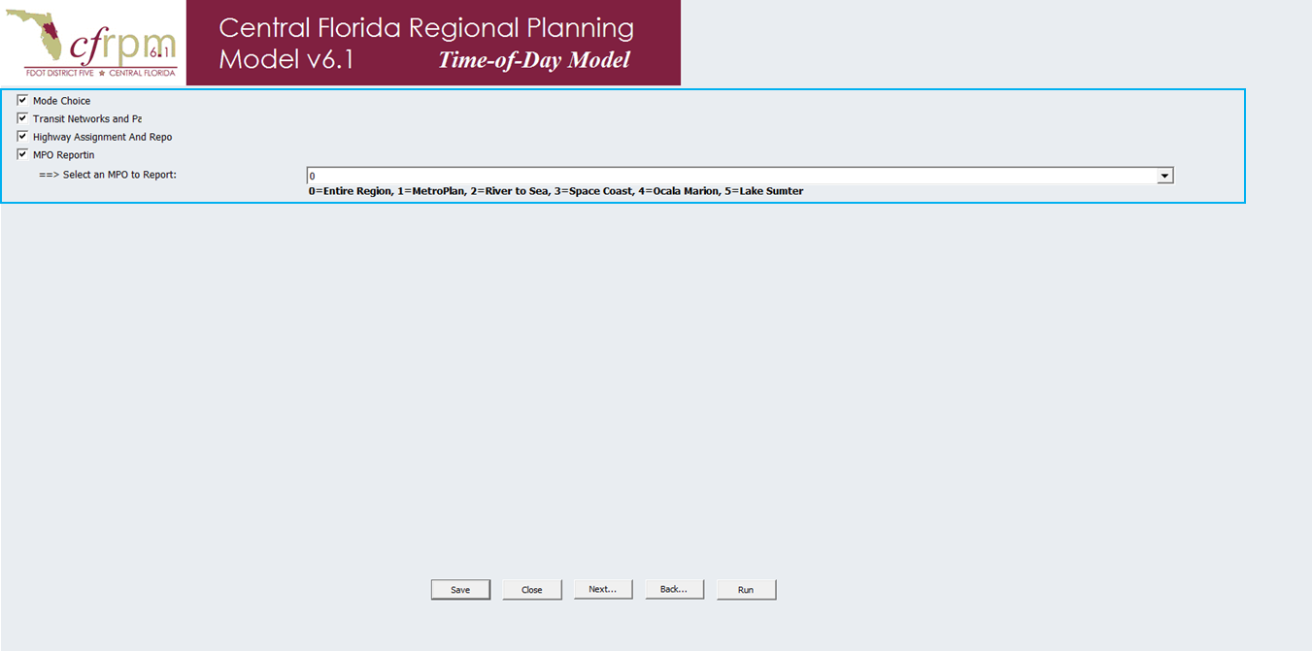

Figure 2‑3: CFRPM GUI Page 2

Figure 2‑4 through Figure 2‑7 display the model parameters from the GUI. Generally these parameters should not be changed, as they specify basic behavioral parameters and model controls. ***The user should have a full understanding of any parameters he or she modifies on these pages, and what the likely implications are for the model results.***

The one exception is the “select link/select zone” parameter shown in Figure 2‑5. The user must input the link(s) or zone(s) here. These fields are freeform and values must be correctly entered as character or the application(s) won’t work. Selected link and selected zone options are executed through separate model applications.

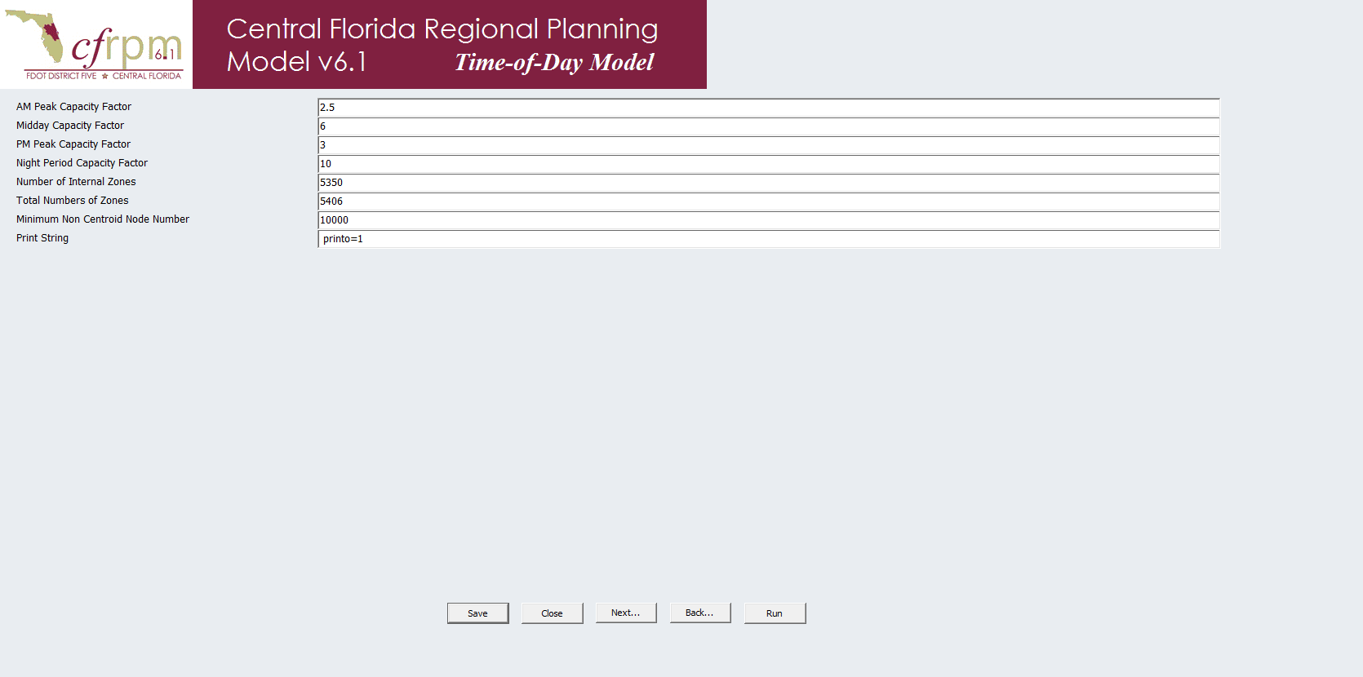

Figure 2‑4: CFRPM GUI Page 3

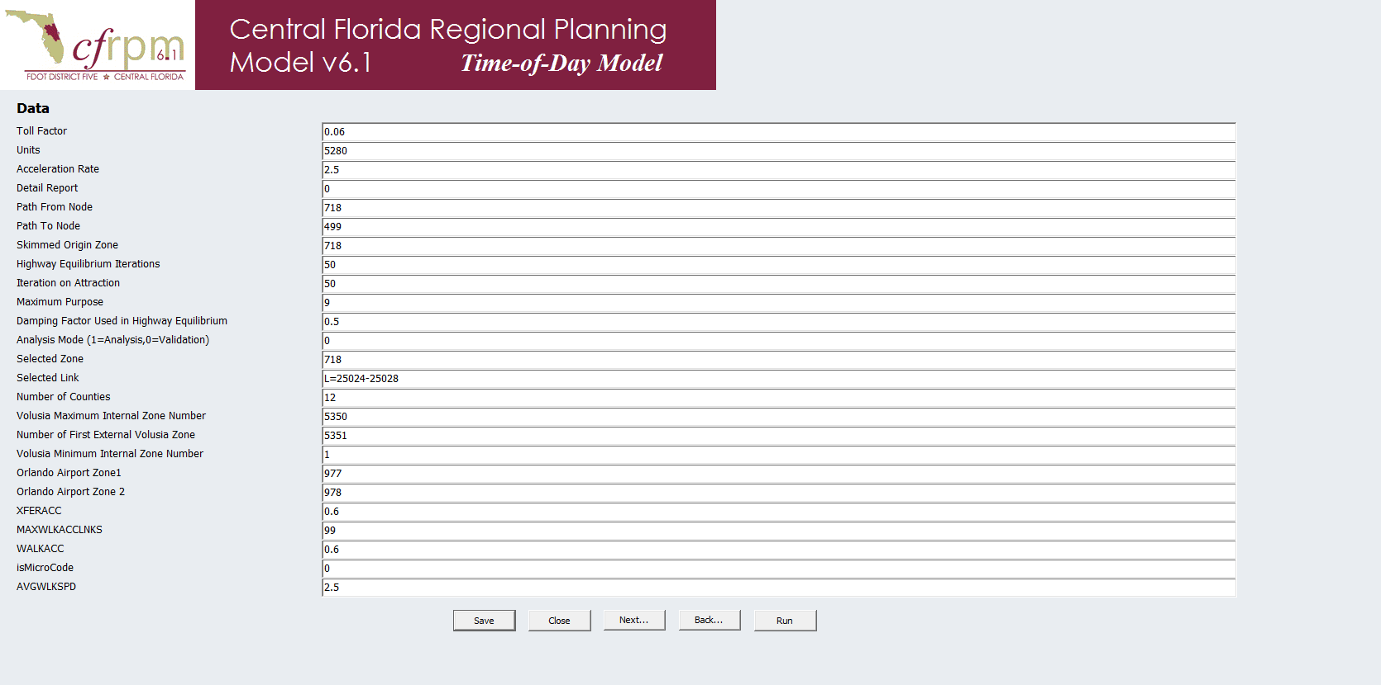

Figure 2‑5: CFRPM GUI Page 4

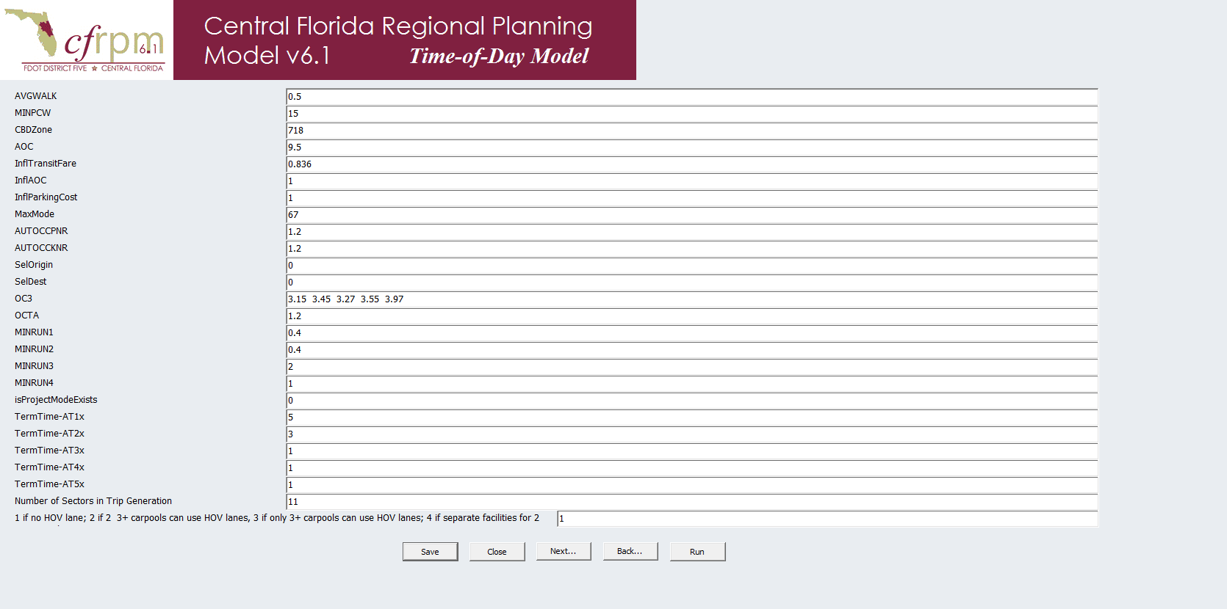

Figure 2‑6: CFRPM GUI Page 5

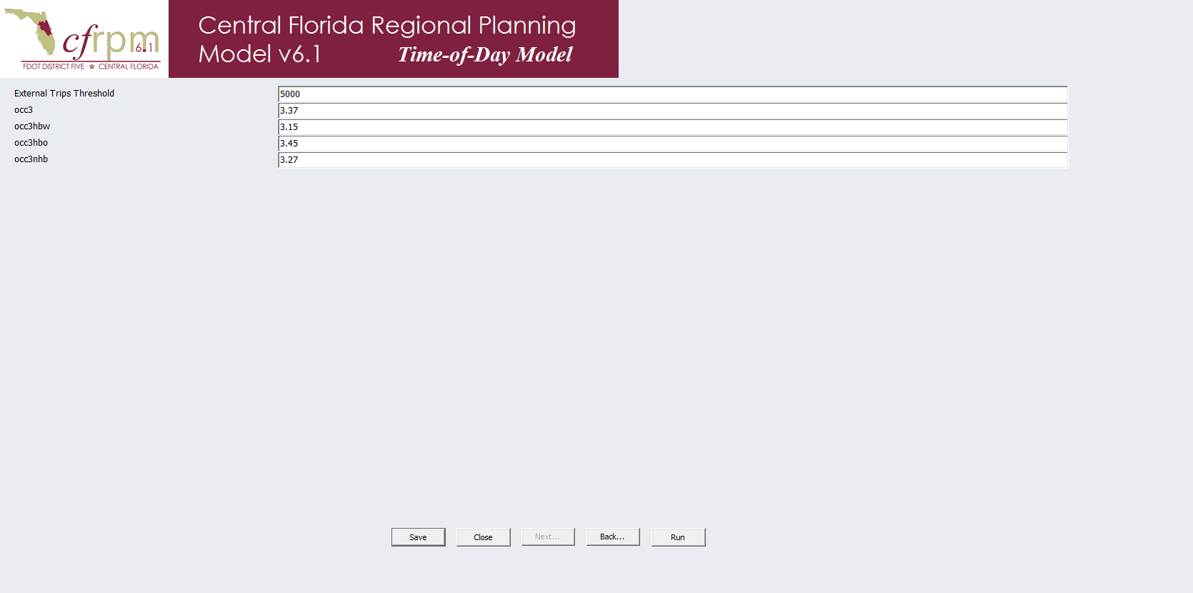

Figure 2‑7: CFRPM GUI Page 6

## Catalog Keys

There are 94 Keys in the CFRPM 6.1 catalog. The new and/or modified keys related to the GUI are shown in Table 2‑1. Following Table 2‑1 is 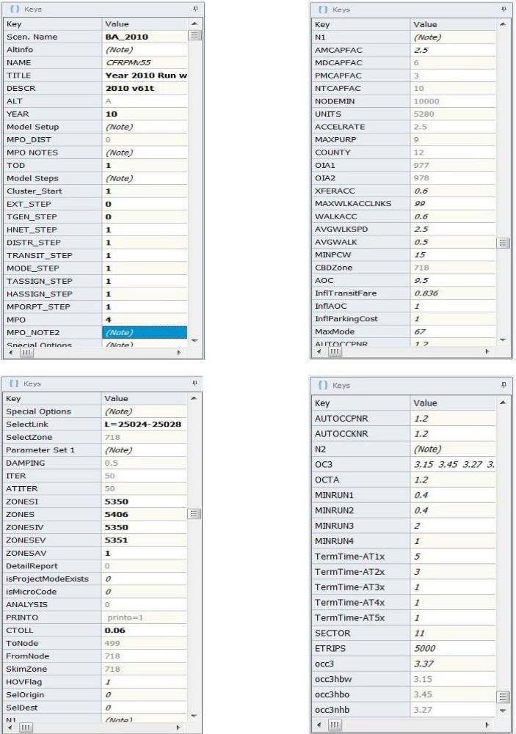

Figure 2‑8 which shows the keys in the interface.

Table 2‑1: New or Modified Catalog Keys

|  |  |
| --- | --- |
| **Key** | **Definition** |
| Altinfo | New Note key used as a heading for the alternative information section of the GUI. Also informs the user to avoid using any special characters as this can cause the program to fail. |
| ALT | Modified key used to designate the alternative of the scenario. Represented by one of the 26 letters in the alphabet. Converted to a drop down list instead of free form input to avoid errant entries. |
| YEAR | Modified key used to designate the two digit year of the scenario. Represented by a number between 01 and 99. Converted to a drop down list instead of free form input to avoid errant entries. |
| Model Setup | New Note key used as a heading for the setup of the model to run model districting and either daily or time of day options in the GUI. |
| MPO_DIST | New key used to designate how the user wishes the districting to be run. Setup as a drop down list to avoid errant entries in the GUI. |
| MPO NOTES | New Note key used to define the districting options for selection in the MPO_DIST key in the GUI. |
| Model Steps | New Note key used as a heading for the steps of the model to run in the GUI. |
| EXT_STEP | New key used for the selection of the External Trip step in the GUI. |
| TGEN_STEP | New key used for the selection of the Trip Generation step in the GUI. |
| HNET_STEP | New key used for the selection of the Highway Network step in the GUI. |
| DISTR_STEP | New key used for the selection of the Trip Distribution step in the GUI. |
| TRANSIT_STEP | New key used for the selection of the Transit Network step in the GUI. |
| MODE_STEP | New key used for the selection of the Mode Choice step in the GUI. |
| TASSIGN_STEP | New key used for the selection of the Transit Assignment step in the GUI. |
| HASSIGN_STEP | New key used for the selection of the Highway Assignment step in the GUI. |
| MPORPT_STEP | New key used for the selection of the MPO Report step in the GUI. |
| MPO | New key used for the selection of which MPO to report in the MPO Report step in the GUI. |
| MPO_NOTE2 | New Note key used to define the MPO numbers for selection in the GUI. |
| Special Option: | New Note key used as a heading for the Select Link and Zone applications in the GUI. |
| Parameter Set 1 | New Note key used as a heading for the first page of Parameters in the GUI. |
| N1 & N2 | New Note keys used as a heading for the second and third pages of Parameters in the GUI. |



Figure 2‑8: Catalog Keys in GUI

# subarea application

The CFRPM model incorporates the ability to perform a subarea analysis to allow for small-area traffic analysis and efficient evaluation of specific subarea planning issues.

The following sections describe how the SubArea application was created in both the Daily and Time of Day (TOD) versions of CFRPM and how to use it.

## Catalog Keys

There are five (5) keys used in the SubArea application. These keys are described and shown in Table 3‑1 and are found in the model as shown in the model interface shown in Figure 3‑1. The first two keys used in the SubArea application already existed in the model and are documented in Table 2‑1 and noted again in Table 3‑1 for purposes of understanding this process.

There are three (3) new keys required for the SubArea application in both the Daily and TOD modes which include 2 note keys and 1 “check box” key as described in Table 3‑1.

Table 3‑1: SubArea Application Catalog Key Definitions

|  |  |
| --- | --- |
| **Key** | **Definition** |
| MPO_DIST | Key used to designate how the user wishes the districting to be run. Setup as a drop down list to avoid errant entries in the GUI. |
| MPO NOTES | Note key used to define the districting options for selection in the MPO_DIST key in the GUI. |
| Subnote0 | New Note key used as a heading for the User-Defined Subarea/Windowed Network section of the GUI. |
| Subnote1 | New Note key used to define the steps the user must take to execute their own Subarea for selection. |
| UserDefinedSubarea | New key used to select the users Defined Windowed Subarea step in the GUI. |

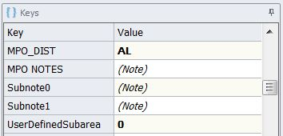

Figure 3‑1: SubArea Application Keys

## Use of the SubArea Application

As shown in the description of the catalog keys in Section 2.2 of this guide in Figure 2‑2, the subarea process requires the user to specify the necessary attributes required to properly perform the analysis. Table 3‑2 shows the definition of the keys specific to running the SubArea procedure.

The SubArea section of the GUI in both the Daily and TOD models allow the user to select how the districting is implemented during the model run.

Table 3‑2: MPO_DIST Catalog Key Definitions

|  |  |
| --- | --- |
| **Key Value** | **Definition** |
| xx | This selection runs the Entire Region as Zones. |
| AL | This selection runs the Entire Region as Districts. |
| MP | This selection runs MetroPlan as Zones and the rest of the model area as Districts. *The MetroPlan area additionally includes all of Polk County. |
| RS | This selection runs River to the Sea TPO as Zones and the rest of the model area as Districts. |
| SC | This selection runs Space Coast TPO as Zones and the rest of the model area as Districts. *The Space Coast area additionally includes the northern half of Indian River County. |
| OM | This selection runs Ocala/Marion TPO as Zones and the rest of the model area as Districts. |
| LS | This selection runs Lake/Sumter MPO as Zones and the rest of the model area as Districts. |

The model can be run four (4) different ways and is accomplished through a drop down list for the first three options and through a polygon procedure for the last. Table 3‑2 shows the key needed for each option.

1. The user can select a specific MPO/TPO area. Once selected, the MPO/TPO area is run as TAZs with the rest of the model run as districts.
2. The user can select the entire region as a TAZ. Once selected, the whole model area is run as TAZs.
3. The user can select the entire region as districts. Once selected, the whole model area is run as districts.
4. The user can define their own SubArea. Once selected, the model is run with the selected SubArea as TAZs with the rest of the model run as districts.

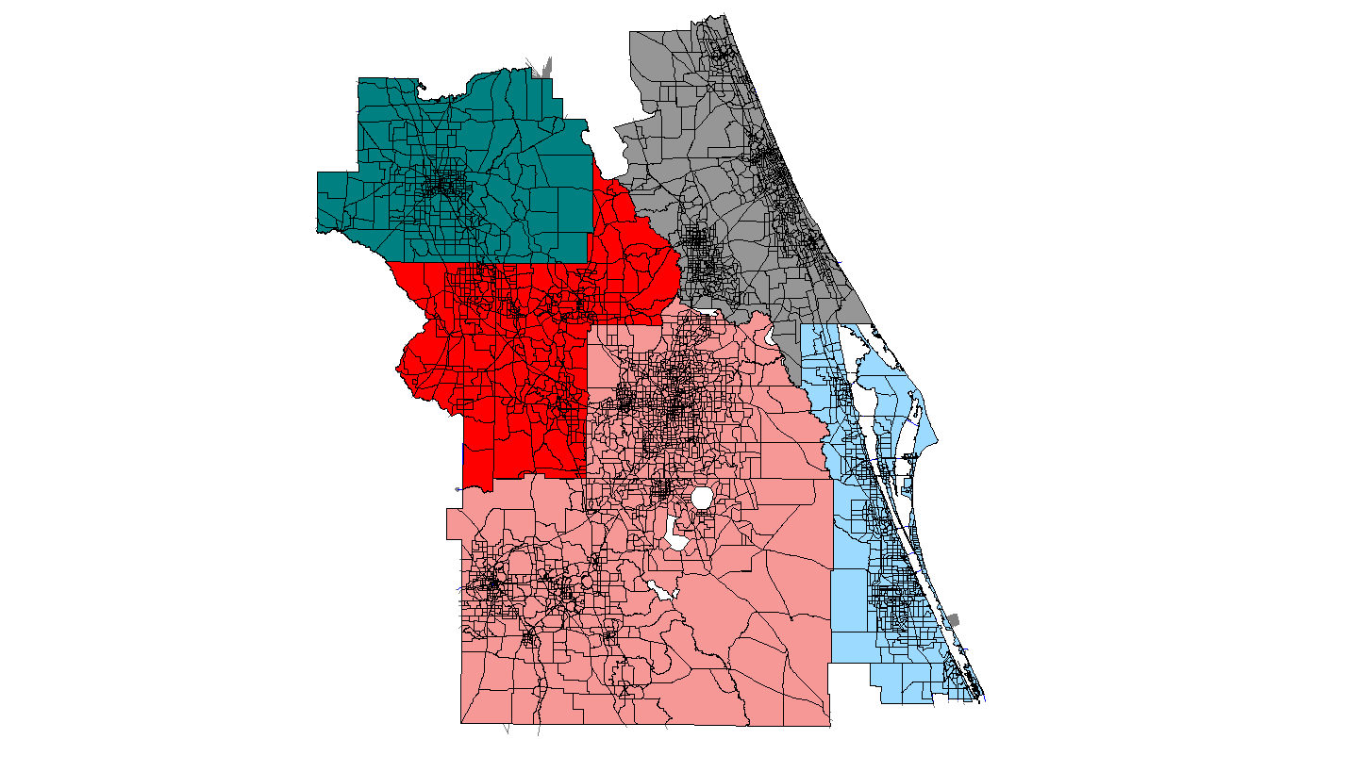

OM

LS

MP

RS

SC

Figure 3‑2: Pre-Defined Districts

To run the model by MPO, the entire region as DISTRICTS or TAZs the user simply selects that option from the drop down menu. As an example, Figure 3‑3 shows the selection of “AL” to run the entire model as Districts.

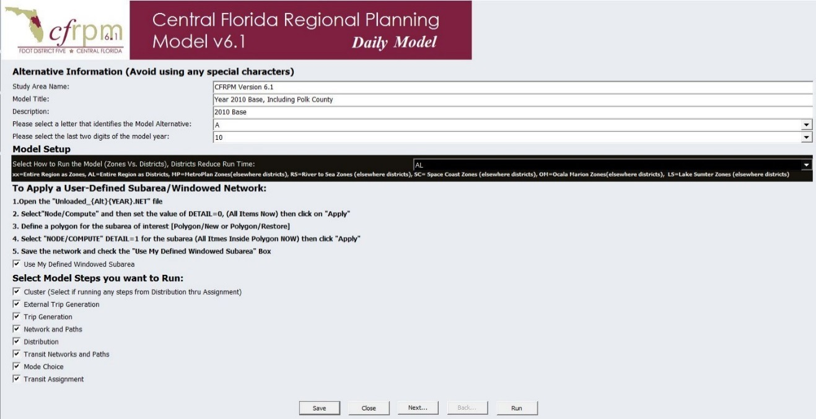Figure 3‑3: Select District/Zone Option

To run the model with a user Defined Windowed SubArea the user follows the instructions located under the GUI heading “To Apply a User-Defined Subarea/Windowed Network”. Figure 3‑4 shows a zoom-in of that portion of the GUI and explains the four user defined preparatory steps.

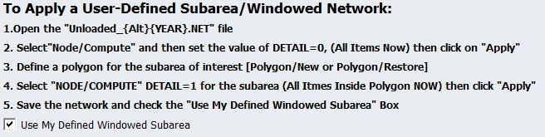Figure 3‑4: User Defined Subarea Steps

The UserDefinedSubarea Keys in Table 3‑3 must also be used in the model run.

Table 3‑3: UserDefinedSubarea Catalog Key Definitions

|  |  |
| --- | --- |
| **Key Value** | **Definition** |
| 0 | Does not run the User Defined Subarea scripts |
| 1 | Runs the User Defined Subarea scripts |

As shown in Figure 3‑5, the first step is to open the input highway network.

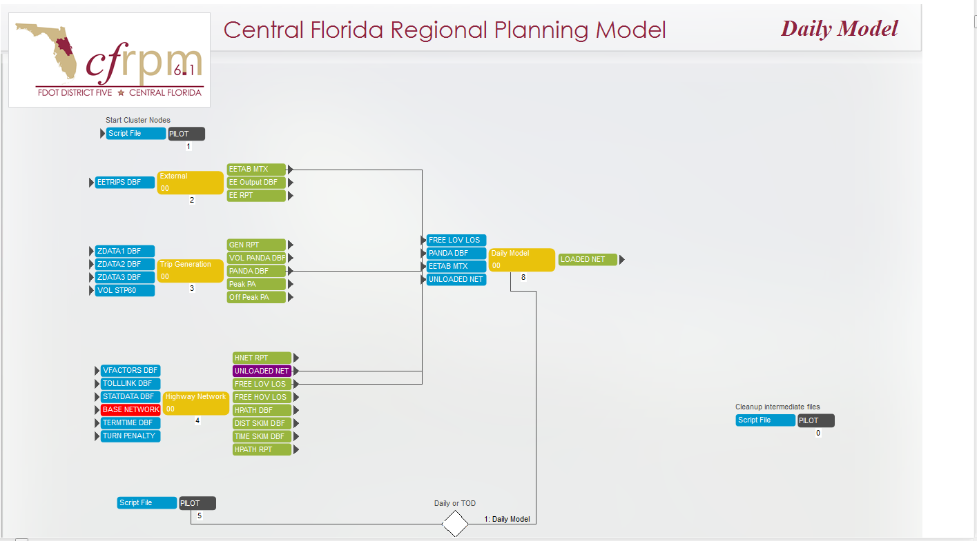

Figure 3‑5: User Defined Subarea Step 1-Edit Network

As shown in Figure 3‑6, the second step is to set the detail=0 to remove any previously selected sets in the model. This can be done by selecting the node menu, then use compute to set the value to zero.

Figure 3‑6: User Defined Subarea Step 2 – Clear Selection Sets

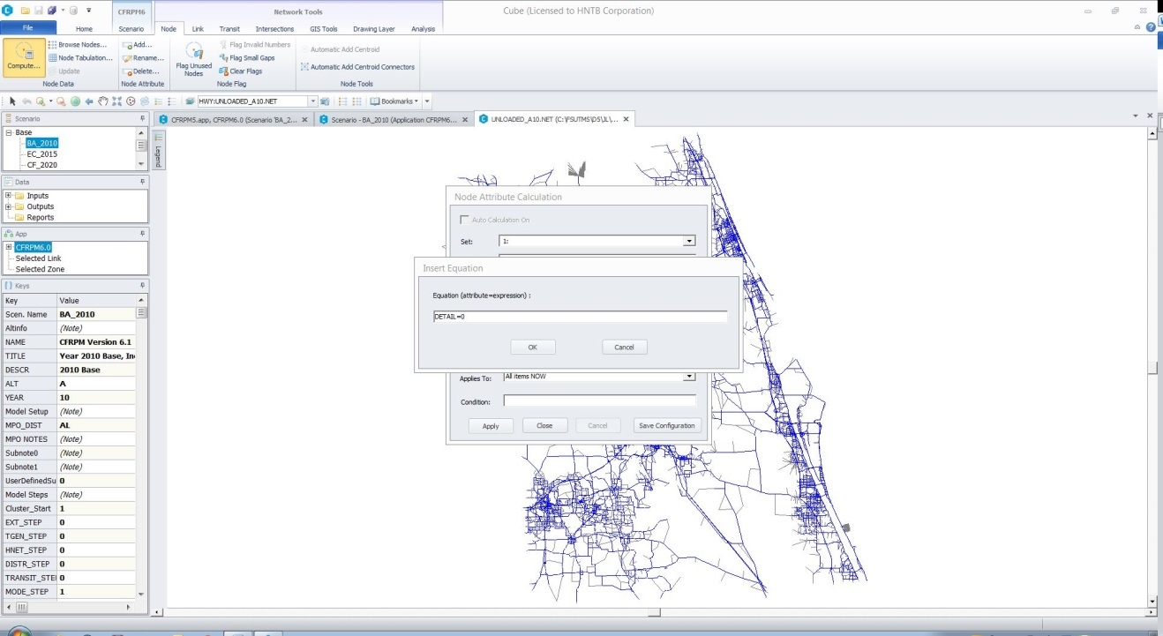

1) Select Node Menu

2) Use Compute

3) Fill Detail=0

As shown in Figure 3‑7, the third step is the user defining the subarea by drawing a polygon around the location they want to analyze. It is good practice is to avoid cutting centroid connectors, and to avoid concave boundary shapes when defining the subarea.

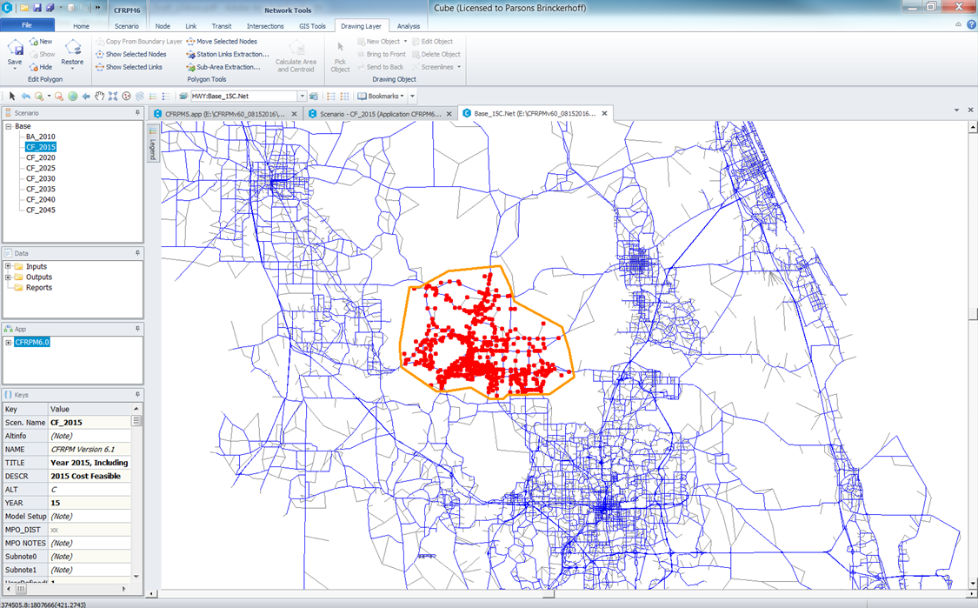Step four is to set the detail=1 as shown in Figure 3‑8 to save this as your subarea selection set.

Figure 3‑7: User Defined Subarea Step 3 – Select Subarea Polygon

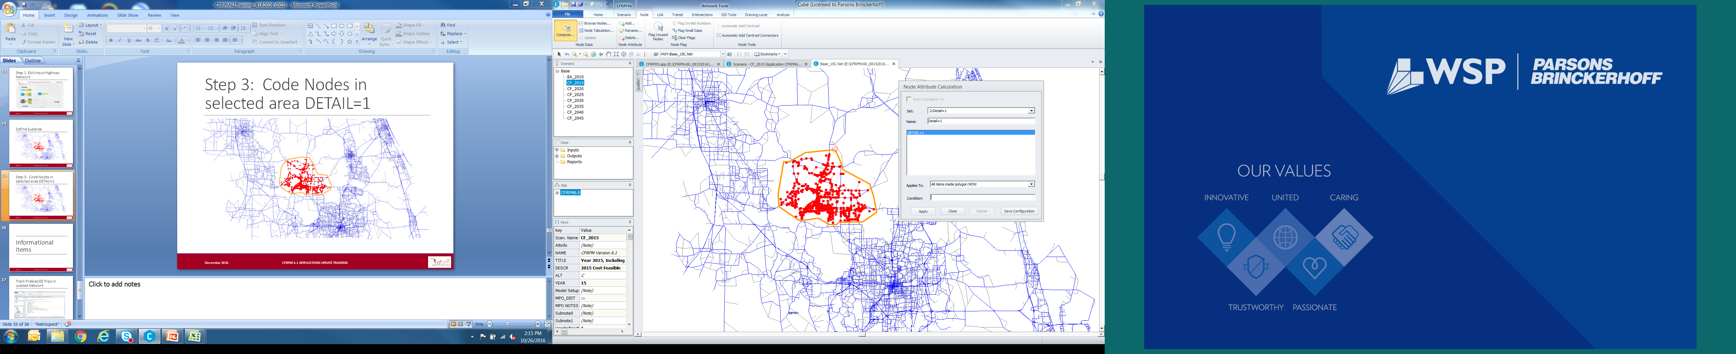

Figure 3‑8: User Defined Subarea Step 4- Save/Set Selection Set

The final step is the select the “check box” for “Use My Defined Windowed Subarea” on the GUI as shown in Figure 3‑9.

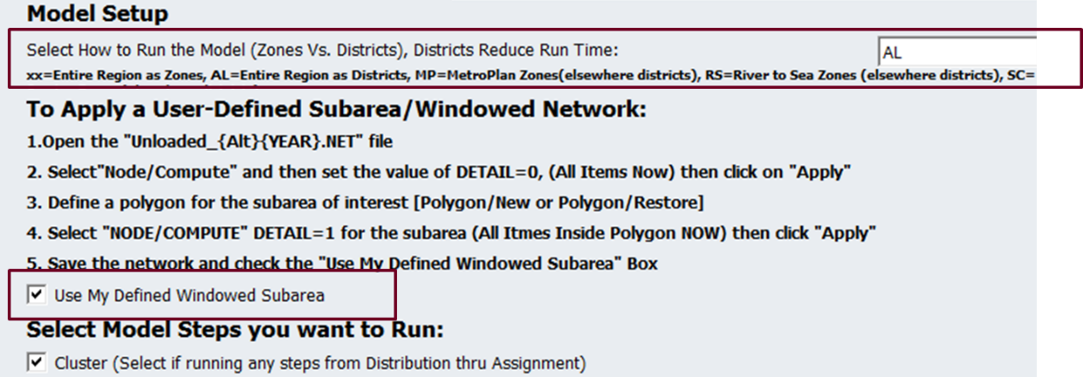

Figure 3‑9: User Defined Subarea Final Step

# MPO Reporting

Having MPO/TPO specific model validation reports allows for understanding impacts in just those areas instead of getting a regional impact. It is also useful for easily calculating MOEs for alternatives analysis at the MPO/TPO scale. Therefore, a series of reports are produced as a part of the CFRPMV6.1 regular model runs[2].

## Network Preparation

The CFRPMV6.1 network was modified to include a new link attribute called “MPO” for every link in the network. This attribute is used to group all the links in the model by their respective MPO/TPO areas so that reports can be generated for each MPO/TPO. **In order for a user to assure the MPO/TPO reports are valid, the user must assure that the links in those regions are properly attributed.** Any network changes made by a user requires that the MPO attribute field be updated.

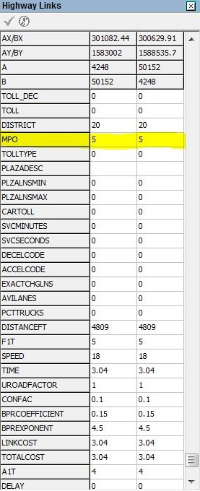Figure 4‑1 shows the attribute on the network layer in the model.

Figure 4‑1: MPO Attribute

The MPO numbers corresponding to each MPO/TPO are shown in Table 4‑1. These are the values the user must code on the network link.

Table 4‑1: MPO Numbers in Highway Network

|  |  |
| --- | --- |
| **MPO #** | **MPO/TPO Name** |
| 0 | Polk & Northern ½ of Indian River Counties |
| 1 | MetroPlan Orlando |
| 2 | River to Sea TPO |
| 3 | Space Coast TPO |
| 4 | Ocala/Marion TPO |
| 5 | Lake – Sumter MPO |

A step has been added to the CFRPM to check for the potential of the following coding errors:

* Any TAZ’s MPO attribute that does not reflect the proper coding based on the current CFRPM 6 internal TAZ range shown in Table 4‑2.
* The MPO attribute was found to be coded as 0 for any roadway input network node

Table 4‑2: MPO Specific Range

|  |  |  |
| --- | --- | --- |
| **MPO/TPO** | **MPO Code** | **CFRPM 6.1** |
| MetroPlan Orlando and Polk County | 1 | 1-1600 (Metroplan)  5101-5850 (Polk) |
| River to Sea TPO and Flagler County | 2 | 2051-3250 (River to Sea)  4851-5100 (Flagler) |
| Space Coast TPO and northern Indian River County | 3 | 3251-4050 (Space Coast)  5851-6000 (Indian River) |
| Ocala/Marion TPO | 4 | 4051-4600 (Ocala/Marion TPO) |
| Lake-Sumter TPO | 5 | 1601-2050 (Lake)  4601-4850 (Sumter) |

If an error occurs related to the MPO coding issue the model will stop processing.

## Summary Reports

The CFRPM includes summary reports at the regional and district level and includes each major model step for each of the MPO/TPOs in the region. Figure 4‑2 displays the model reporting application screen that shows the scripts for each MPO/TPO.

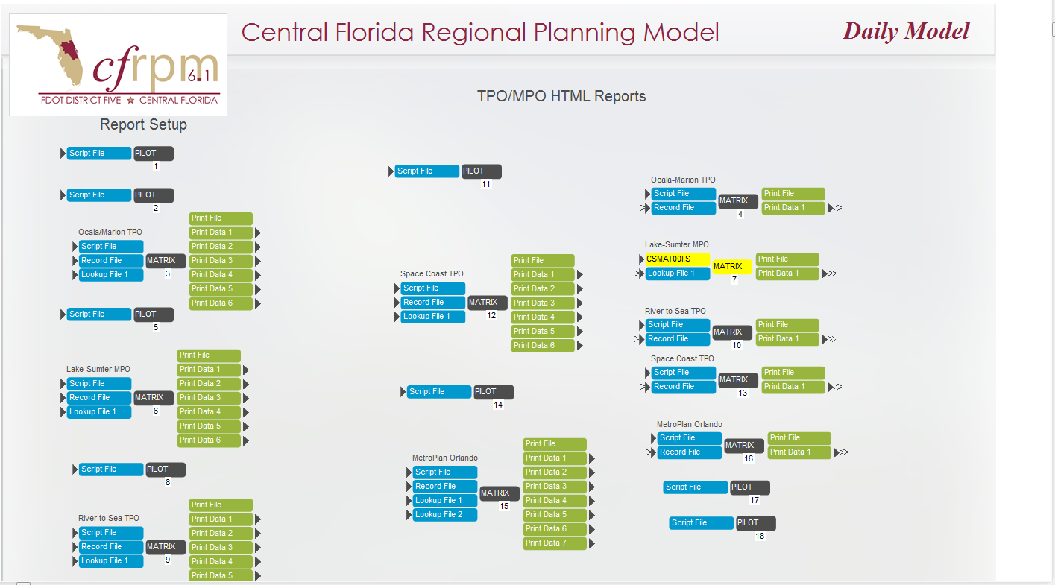

Figure 4‑2: Model Report Application

The CFRPM utilizes HTML for its current reporting format. The HTML formatting was retained and updated to include the individual MPO/TPO reports. Figure 4‑3 shows the user where to find the summary reports generated during the model run. Figure 4‑4 shows the report initial page where the user can choose what reports to view.

These reports may be viewed by dragging the *.rpt files to an open excel application window to edit them or in an internet window for viewing.

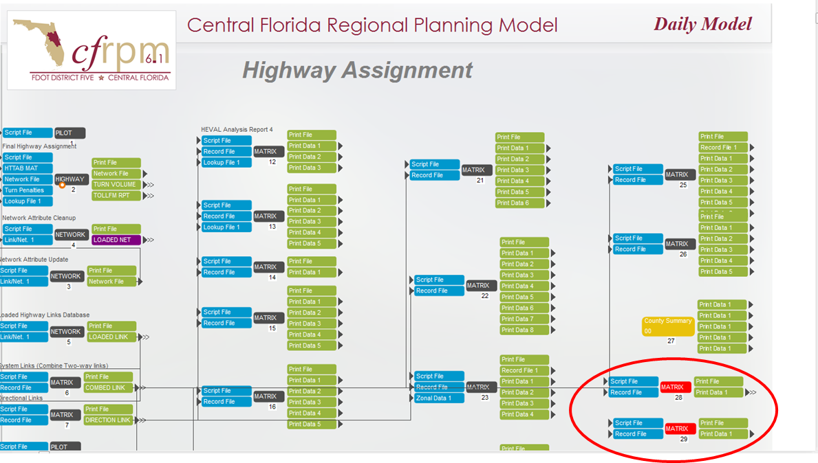

Figure 4‑3: Summary Report Location

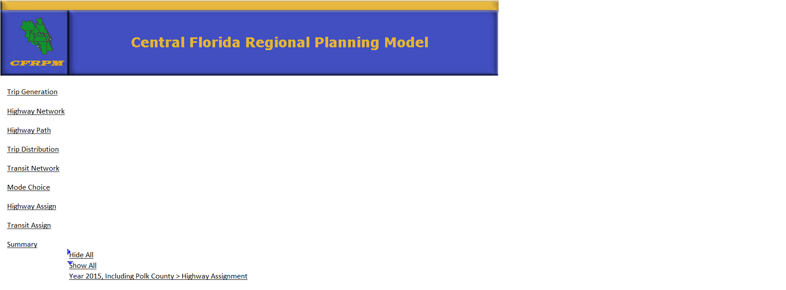

Figure 4‑4: Summary Report Initial Page

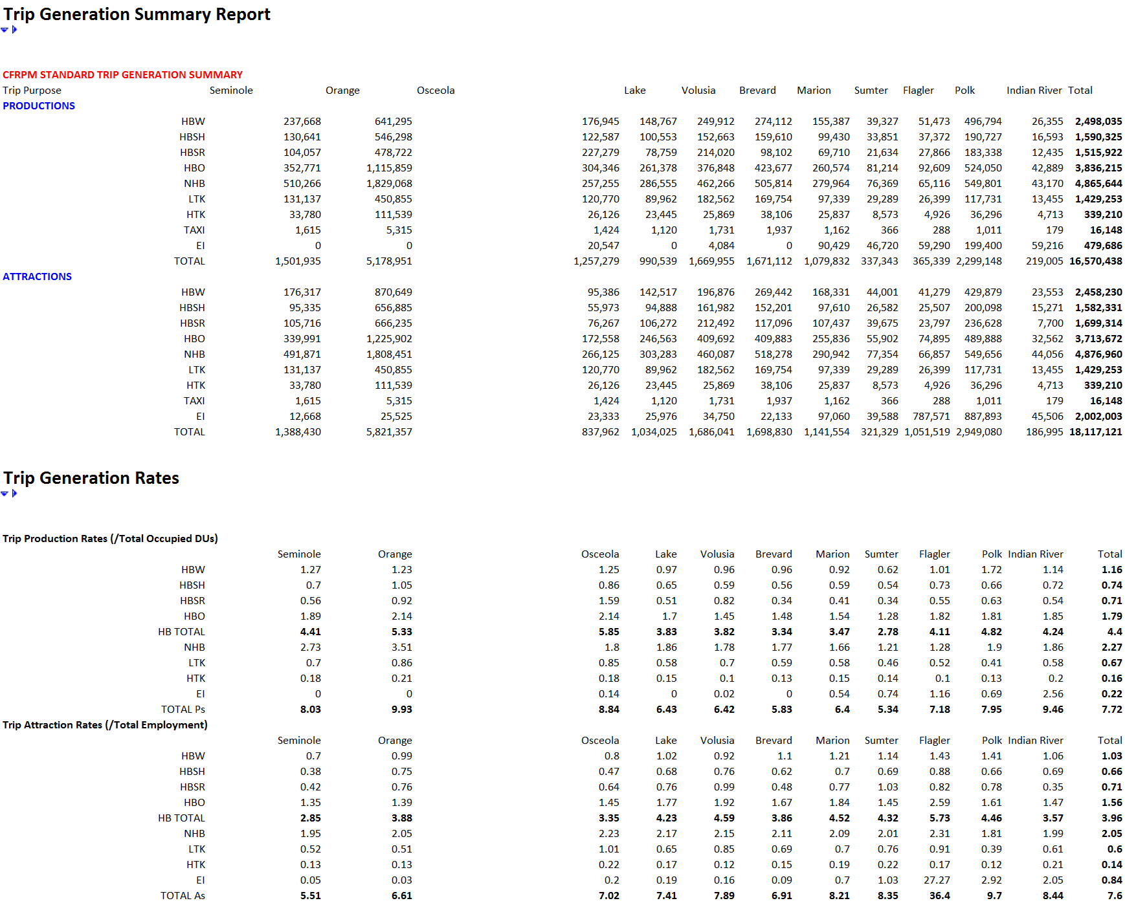Figure 4‑5 shows an example of what a user will see if they click on the “Trip Generation” report link from Figure 4‑4.

Figure 4‑5: Example Trip Generation Report

The traditional “HEVAL” reports are stratified by MPO, number of lanes and facility type, along with specific MPO reports and can be found in the report called HASSIGN.RPT. The information output is:

HEVAL Reports

* + By Area Type, number of Lanes and Facility Types
  + Links and percent of links
  + Percent of Links with Counts
  + System Miles, Lane miles
  + Average Link Length
  + Volume, VMT and VHT for Counted Links – assigned and counts
  + Volume, VMT and VHT for all links
  + Freeflow and congested speeds
  + Screenline volumes
  + RMSE reports
  + By MPO

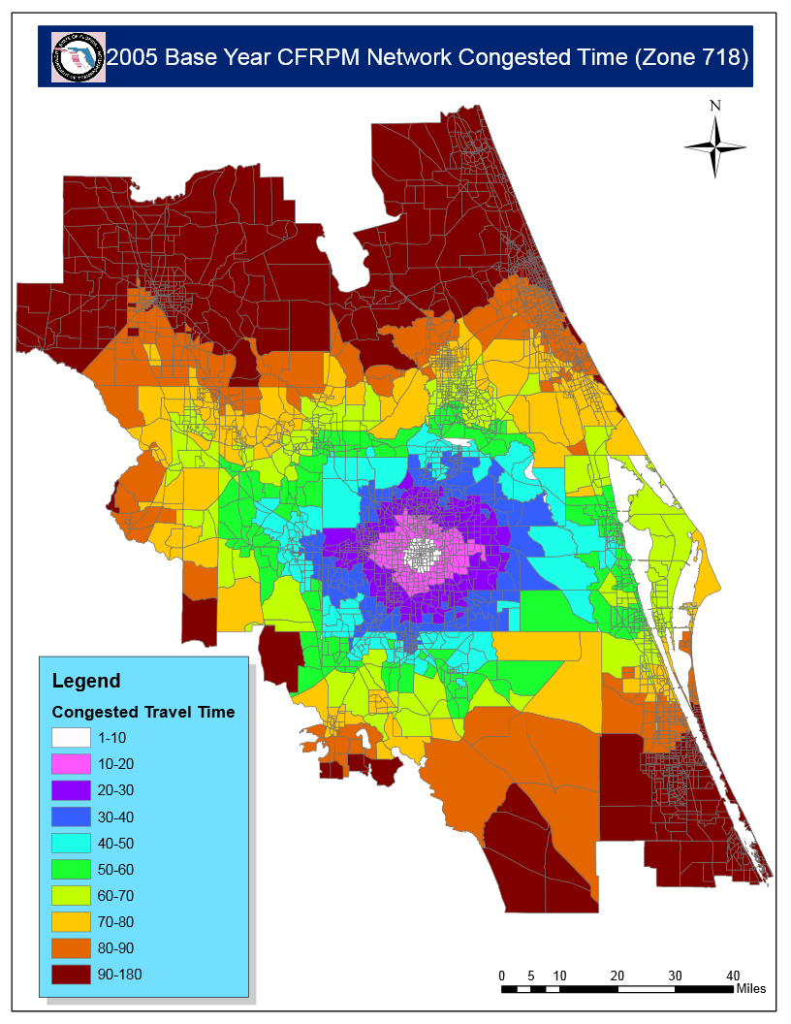In addition, several graphical outputs of charts and figures are produced to help users interpret the data. Figure 4‑6 shows one of those graphics.

Figure 4‑6: Example Congested Travel Time Graphic

# Using Unused Zones

The CFRPM network contains a set of unused, or dummy zone centroids, which can be used for specialized studies where more detail is required like subdividing zones to reflect transit service improvements or to represent new development or special generators.

There are 612 unused or dummy zone centroids reserved for use in subdividing existing zones in the CFRPM. Figure 5‑1 shows a map of MPO/TPO districts color coded and the location of available unused centroids, designated by the thick colored lines on the figure.

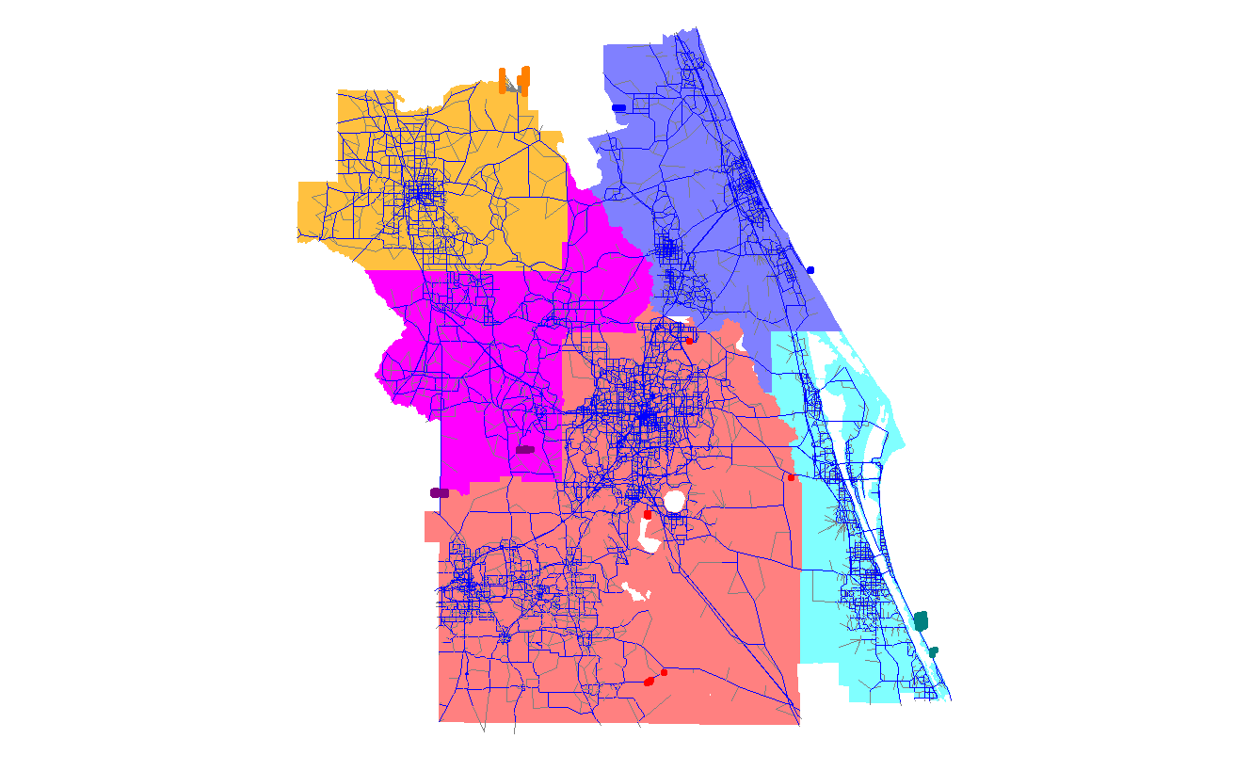

Figure 5‑1: Districts and Unused Zones

Users can use those dummy zones but must edit them using the following steps:

1. Disconnect the dummy zone – select an unused zone centroid in the MPO/TPO area where you will be subdividing zones. See Table 5 1 for the list of available unused zones for each MPO/TPO area. Disconnect by deleting the link connected to the selected dummy zone centroid.
2. Move to desired location by dragging the node to the new location. Save the network.
3. Re-connect the new centroid to the network with a centroid connector. Copy a nearby centroid connector to obtain the link attributes. Check to make sure that the new link and node attributes are correct, including the TSNAME node field.
4. Make any necessary modifications to other existing zone centroids to reflect new subdivided zone boundaries.
5. Update and modify the socioeconomic data ZDATA files to reflect the new subdivided zones.

Table 5‑1: MPO/TPO Zone Ranges

|  |  |  |  |
| --- | --- | --- | --- |
| MPO Code | MPO/TPO | Zones (6.0) | Unused Zones |
| 1 | MetroPlan Orlando and Polk county | 1-1400, 4601-5300 (MetroPlan, Polk) | 231, 233-300, 1012-1015, 1098-1100, 1353-1400, 4677-4688, 4804, 4824, 4835, 5023, 5176-5177, 5230-5300 |
| 2 | River to Sea TPO and Flagler County | 1801-2900, 4401-4600 (River To Sea, Flagler) | 2878-2900, 4542-4553, 4562-4564, 4579, 4586-4600 |
| 3 | Space Coast TPO and Indian River County | 2901-3700, 5301-5350 (Space Coast, Indian River) | 3492-3497, 3601-3700, 5338-5350 |
| 4 | Ocala/Marion TPO | 3701-4200  (Ocala/Marion TPO) | 3721-3724, 3745-3749, 3764-3767, 3881-3883, 3899-3900, 4035-4036, 4057-4058, 4089, 4111-4112, 4121-4125, 4128-4131, 4151-4200 |
| 5 | Lake-Sumter TPO | 1401-1800, 4201-4400 (Lake, Sumter) | 1413-1416, 1433-1438, 1450-1454, 1493-1497, 1512-1514, 1579-1584, 1640-1641, 1662-1667, 1679-1681, 1693-1696, 1705, 1720, 1773-1776, 4348-4400 |

1. In addition, the CUBE settings can be changed by the user to move GUI components so that logical groupings can appear on one screen.
2. This was done for both the Daily and the Time of Day models. The Time of Day model was only modified for the AM and PM peak periods and not for all time periods at the request of the FDOT.